

Title: Feline coronaviruses: research, pathogenesis and therapeutics

Author F. Name,1,* Author S. Name,2 Author Name,3Author Name,4
1 Full address and mail.
² Full address and mail.
³ Full address and mail.
* Correspondence:

ABSTRACT
Human Lorem ipsum dolor sit amet, consectetur adipisicing elit, sed do eiusmod tempor incididunt ut labore et dolore magna aliqua. Ut enim ad minim veniam, quis nostrud exercitation ullamco laboris nisi ut aliquip ex ea commodo consequat. Duis aute irure dolor in reprehenderit in voluptate velit esse cillum dolore eu fugiat nulla pariatur. Excepteur sint occaecat cupidatat non proident, sunt in culpa qui officia deserunt mollit anim id est laborum.… Lorem ipsum dolor sit amet, consectetur adipisicing elit, sed do eiusmod tempor incididunt ut labore et dolore magna aliqua. Ut enim ad minim veniam, quis nostrud exercitation ullamco laboris nisi ut aliquip ex ea commodo consequat. Duis aute irure dolor in reprehenderit in voluptate velit esse cillum dolore eu fugiat nulla pariatur. Excepteur sint occaecat cupidatat non proident, sunt in culpa qui officia deserunt mollit anim id est laborum.… Lorem ipsum dolor sit amet, consectetur adipisicing elit, sed do eiusmod tempor incididunt ut labore et dolore magna aliqua. Ut enim ad minim veniam, quis nostrud exercitation ullamco laboris nisi ut aliquip ex ea commodo consequat.//9pt

INTRODUCTION
Background
Literature review and research gap
Objectives and novelty

METHODS

RESULTS

DISCUSSION

CONCLUSIONS

DECLARATION OF INTERESTS
The authors declare no competing interests.

INTRODUCTION
Reference must be listed at the end of the paper in alphabetical order and not numbered. For multiple publications by the same author, those by the author alone are listed first, those with two authors listed after these and any with three or more authors must be given up to a maximum of six and any more should be indicated by italic et al., and year (Last name et al., 2012).
Reference accuracy, suitability and use the convenient location is one of the most important elements in an article. In journals, uniform and regular reference is an indicator of the quality of articles covering. References responsibility for the accuracy and belong to the authors. Therefore, the content of your article is very good, but we wish to inform that will be rejected if it is not use appropriate journal style in text body and references section. For this purpose, refer to the rules of our journal and/or sent in additional examples, please use to the attached template.
Citation of literature references in the text should be given at the appropriate place by the author's name followed by year in parentheses. Should there be more than two authors; the first author's name should be followed by et al. When there are two or more papers by the same author(s) appearing in the same year these should be distinguished by a, b, c, etc. after the year.
All references cited in the text should be listed at the end of the paper on a separate page according to the Harvard system, i.e., arranged in alphabetical order according to the first author followed by the second author, then with all papers with more than two authors being arranged in chronological order.
Literature references must be complete, including initials of author(s) cited, title of paper referred to, and title of journal, year, followed by volume and first and last pages of article. This is basic sample style:
Churchland, P. S. Exploring the causal underpinning of determination, resolve, and will. Neuron 2013; 80: 1337–1338.
The form of literature references to books should be author, initials, title of book, volume or edition, publisher, city, year and page number(s) referred to.
We suggest;
- Ask your friend to read the article or someone else. It would be good to read a different one. Someone who has escaped from your eyes, he/she can see mistakes.
Because of this formalism which we are apologize. Within two weeks, please send back the corrected version. Late in cases where we wish to inform of the article will be canceled automatically from our system.
Journal names should be abbreviated according to the
List of title word abbreviations: http://www.issn.org/2-22661-LTWA-online.php
Mathematics should be prepared using Word’s built-in ‘Equation Editor’ or the full MathType. Please DO NOT USE Word’s ‘Insert Symbol’ command. Symbols inserted in this way may not appear in the PDF file of your article—they often ‘drop out’. Instead, for example, to type Greek characters, type the corresponding Latin character (e.g., ‘a’ for α and manually change the font to Symbol using Format →Font and then select ‘Symbol’ font. Please use Microsoft Word Equation editor or Math type.
Equations should be numbered sequentially throughout the text (i.e., (1), (2), (3)...) or numbered by section (i.e., (1.1), (1.2), (2.1)....) depending on your preference. In articles with several appendices equation numbering by section is useful in the appendices even when sequential numbering has been used throughout the main body of the text: for example, A.1, A.2,…,B.1, B.2,….

(1)

In addition to the figures being embedded in the text (Word file) of your article, you are asked, where possible, to supply all figures as separate graphics files in any of the following file formats: EPS, PDF, WMF, TIFF, JPEG and BMP. You can supply a PDF file of your paper but you must also supply the original Word file with embedded graphics and separate graphics files where possible. The figures should be clear, easy to read and of good quality. Characters should appear as they would be set in the main body of the article.

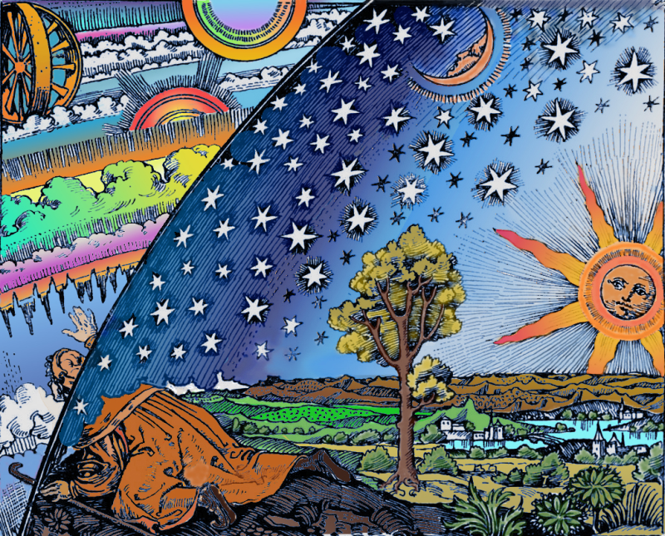
Figure 1. Figure explanation Figure explanation Figure explanation Figure explanation.

Table 1. Explanations about table. This is full page length table.
Individuals with | Individuals with |  |  | Age | Range | Duration | Another
Individuals with | xzxxx | xzxxx |  | 42 | 16-64 | sdsd | dada
Individuals with | xzxxx | xzxxx |  | 42 | 22-55 | dadada | dada
Individuals with | xzxxx | xzxxx |  | 55 | 34-86 | sdsd | dada
Individuals with | xzxxx | xzxxx |  | 76 | 65-89 | dadada | dada
Individuals with | xzxxx | xzxxx |  | 33 | 25-49 | sdsd | dada
Individuals with | xzxxx | xzxxx |  | 66 | 34-79 | dadada | dada
Explanations of specific symbols within the table. Explanations of specific symbols within the table.

The title of your article should be used as the running head of your article. If the title is too long, please use a short version of the title that can also be used in the final print version of your article.

Footnotes should be only be used when essential, and if required should be used only for brief notes that do not fit conveniently into the text. Please, use “insert footnote” with numbering 1, 2, 3..., below the every page.

REFERENCES
- E.S. Brondizio, J. Settele, and S. Diaz, et al., eds. (2019). IPBES. Global Assessment Report on Biodiversity and Ecosystem Services (IPBES Secretariat).
- Díaz, S., Settele, J., Brondízio, E.S., et al. (2019). Pervasive human-driven decline of life on Earth points to the need for transformative change. Science 366, eaax3100. https://doi.org/10.1126/science.aax3100.
- (2022). Convention on Biological Diversity. Decision 15/4: Kunming–Montreal Global Biodiversity Framework. CBD/COP/DEC/15/4. Secretariat of the Convention on. Biological Diversity, 1-15. https://www.cbd.int/doc/decisions/ cop-15/cop-15-dec-04-en.pdf.
- Convention on Biological Diversity. Decision 15/5: Monitoring Framework for the Kunming–Montreal Global Biodiversity Framework. CBD/COP/DEC/15/5. Secretariat of the Convention on Biological Diversity. https://www.cbd.int/ doc/decisions/cop-15/cop-15-dec-05-en.pdf.
- Pereira, H.M., Ferrier, S., Walters, M., et al. (2013). Essential biodiversity vari-ables. Science 339, 277-278. https://doi.org/10.1126/science.1229931.
- Jetz, W., McGeoch, M.A., Guralnick, R., et al. (2019). Essential biodiversity vari-ables for mapping and monitoring species populations. Nat. Ecol. Evol. 3, 539-551. https://doi.org/10.1038/s41559-019-0826-1.
- Lawrence, A., Rawls, M.L., Jah, M., et al. (2022). The case for space environmen-talism. Nat. Astron. 6, 428-435. https://doi.org/10.1038/s41550-022-01655-6.
- Boley, A.C., and Byers, M. (2021). Satellite mega-constellations create risks in low Earth orbit, the atmosphere and on Earth. Sci. Rep. 11, 10642. https:// doi.org/10.1038/s41598-021-89909-7.
- McDowell, J.C. (2020). The low Earth orbit satellite population and impacts of the SpaceX Starlink constellation. ApJL. 892, L36. https://doi.org/10.3847/ 2041-8213/ab8016.
- United Nations Committee on the Peaceful Uses of Outer Space. Guidelines for the Long-term Sustainability of Outer Space Activities of the Committee on the Peaceful Uses of Outer Space. In: Report of the Committee on the Peaceful Uses of Outer Space, Sixty-second Session (12–21 June 2019). United Nations General Assembly Official Records, Seventy-fourth Session, Supplement No. 20, A/74/20, Annex II. 2019. pp. 50–69.

